(please keep fonts of Template)
TITLE of Abstract (Talk or Poster), Centred, Capital Letters.
All author names, presenting author, centred.
All author affiliations (including city/state & country), centred, italics.
Email address of presenting author

Your abstract should be no longer than 250 words, and (if necessary) one figure or a table.

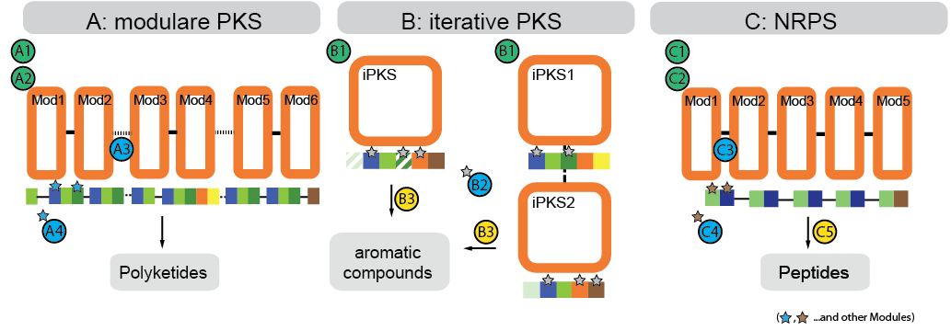
Example figure and caption…, centred.

References
- Reference 1
- Reference 2

